- Audit data viz in Intuit products (what’s good/what’s not)
- Audit data viz outside of Intuit (what works well/what doesn’t)
- Zeho Books
- Xero
- Wave
- Slickpie
- ONEUP
https://wiki.intuit.com/display/HarmonyTools/Data+Visualization+Audit
- Use sliders/switch/various data viz to combine multiple graphs into one
- The ultimate goal is to let data make sense to users.
- Adding animation/interaction increases user’s overall experience

- Investigate where we should take data viz
- Start to think about what we could show/prototype

Places we can add data viz:
- Worker -> the distribution of employees and contractors (skillset, age etc, can have a button for that)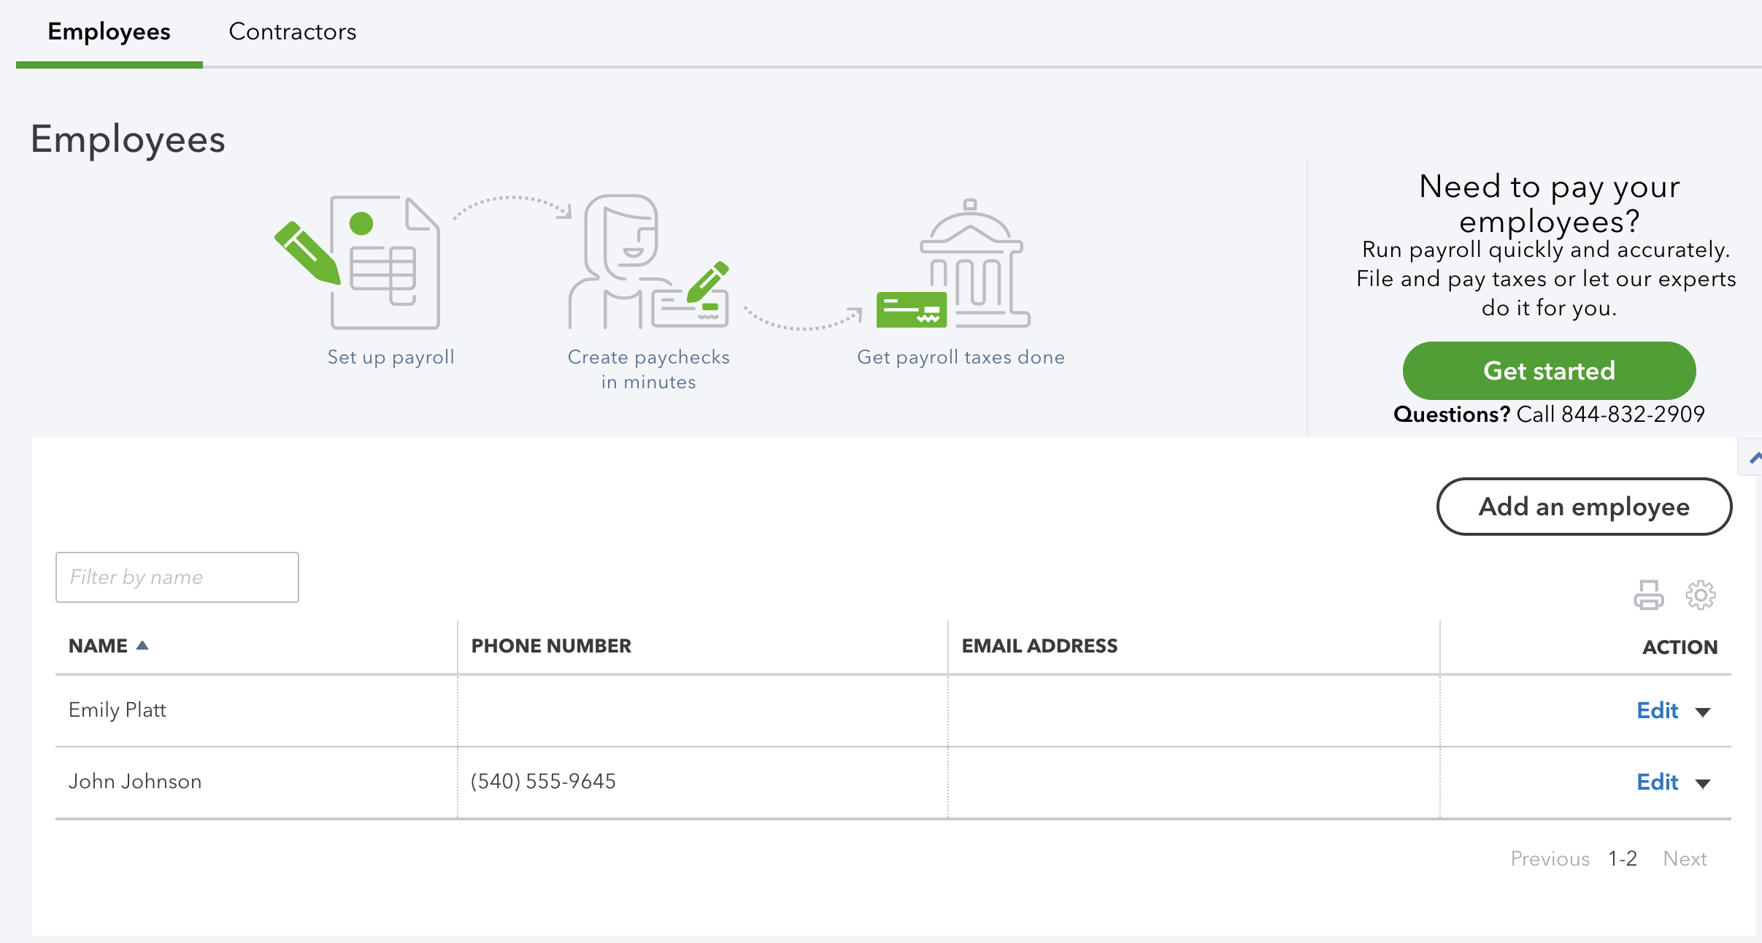
- Expense-expense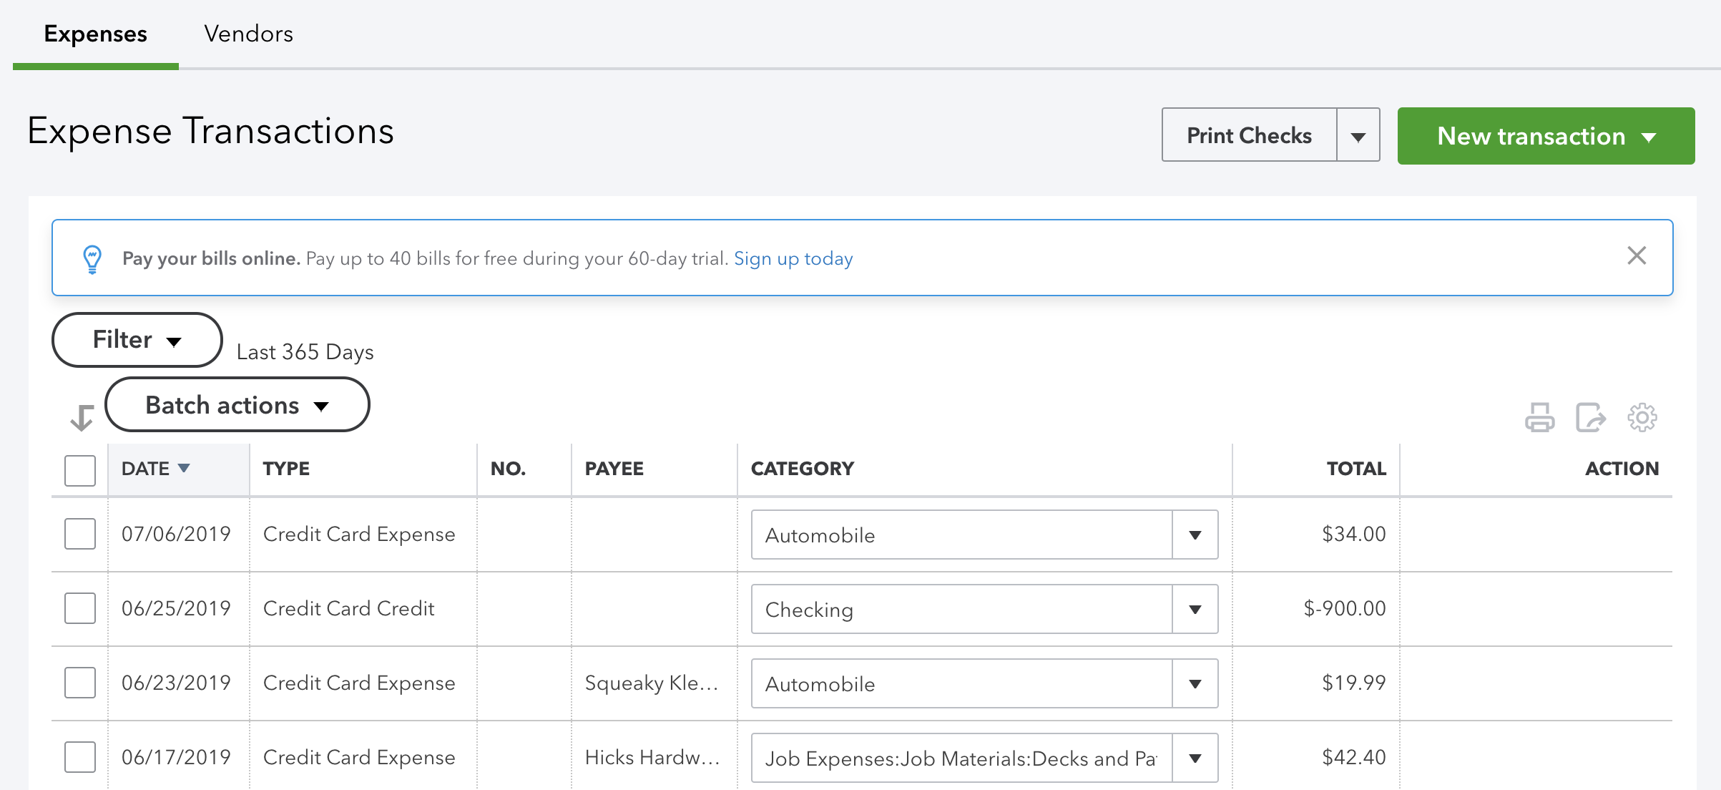

- Report graph page (profit/inventory/sales) Let the profit/loss as the main tab and others as buttons?
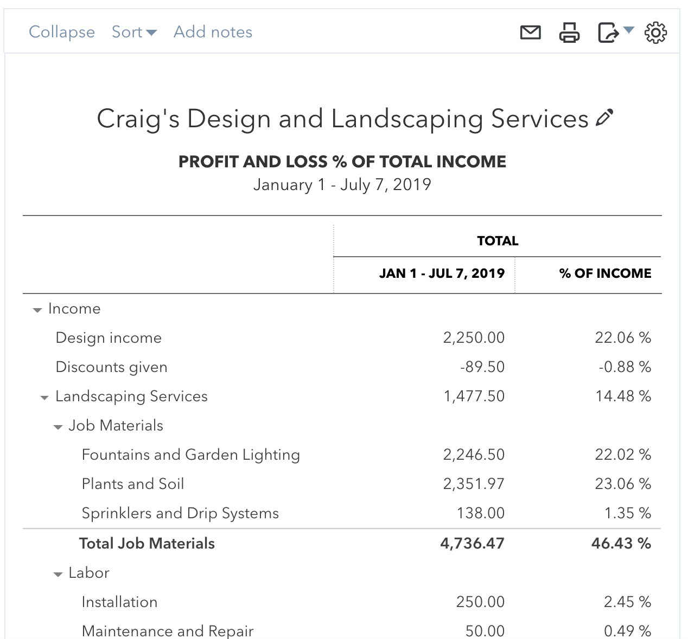
- Tax? (The distribution of salaries and taxes)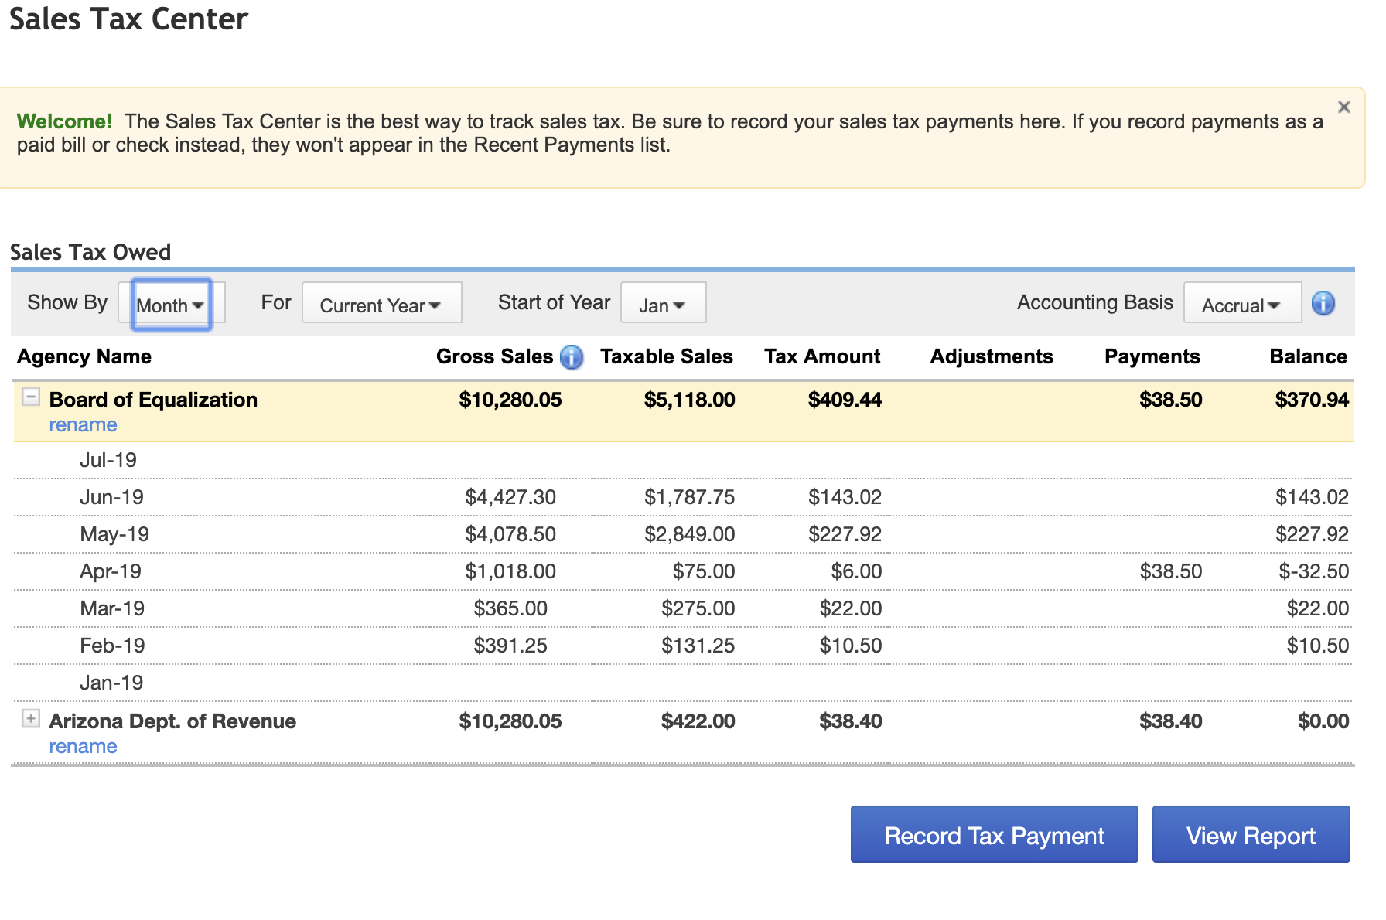
- Sales - Product & Service

Places that we can improve data viz:
- The accounting page 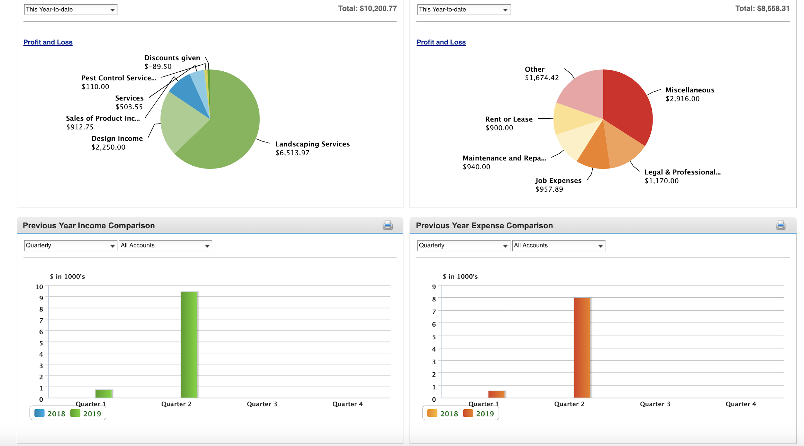

- Dashboard-expense
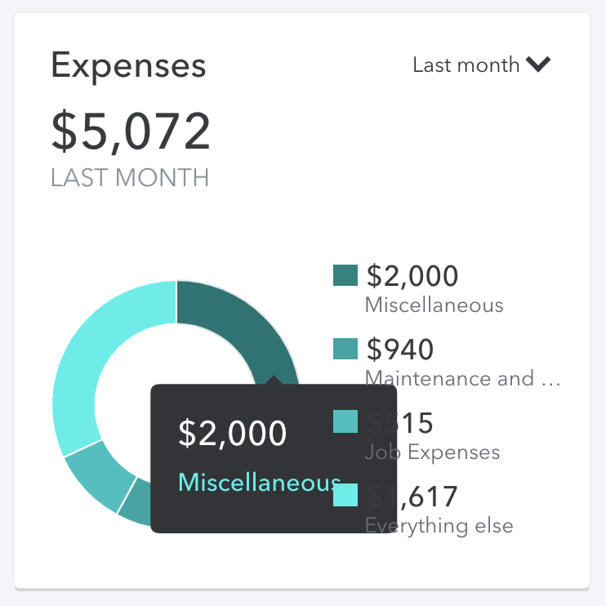
- Expense-vendors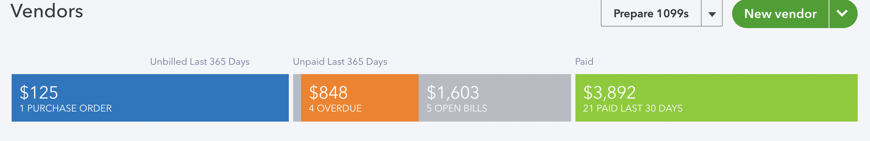

- Project-overview (color, type, etc)

- Invoices -> more time period (7 days?)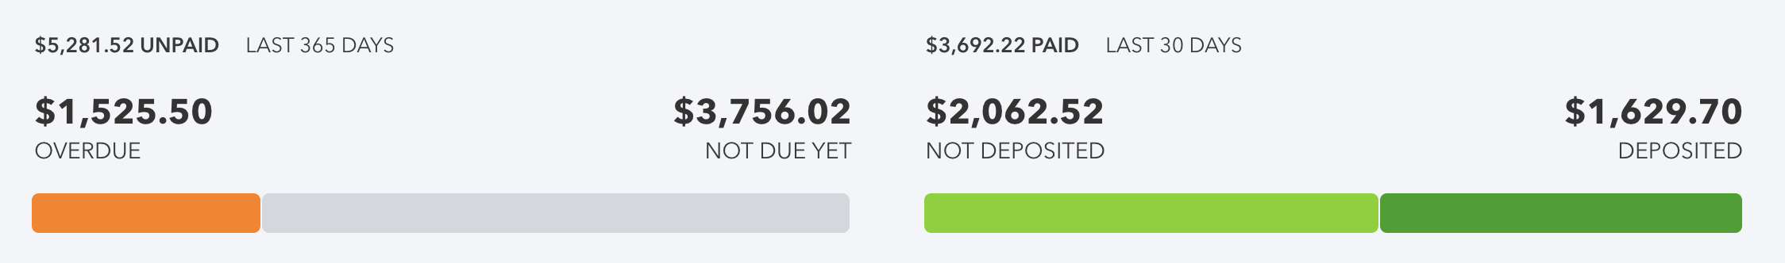

- Banking 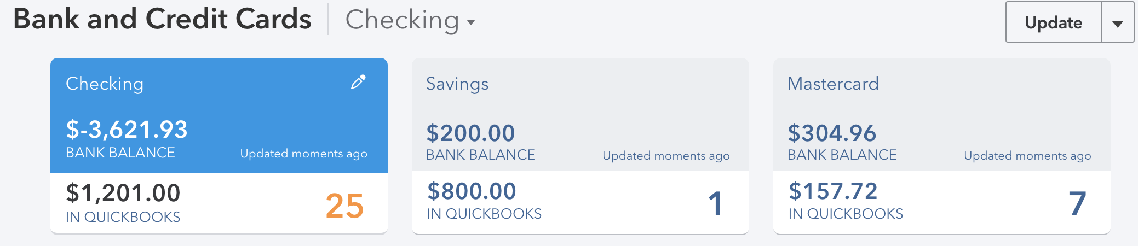

Functions we could add: 1. Slider (time based)
2. Switch
3. Animation/Interaction
4. Play more on the transition of color
5. Dark mode -> QBSE

